Non-metro

Area Agency on Aging

EMERGENCY MENU

guide

1 week shelf stable emergency menu

4 week pandemic menu of 1 hot AND 1-2 frozen meals

Equipment / Utensils Needed
FOOD SERVICE IN VARIOUS EMERGENY SITUATIONS

You must always be prepared for the following emergencies.

Situation #1 No safe drinking water
Situation #2 No refrigeration
Situation #3 No cooking areas or serving areas
Situation #4 No electricity
Situation #5 No food deliveries

EQUIPMENT NEEDED

Scoops #6, #8, #10 & #16
Battery Operated Blender
Manual Can Opener
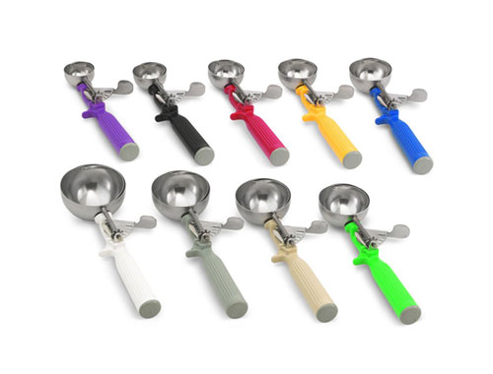
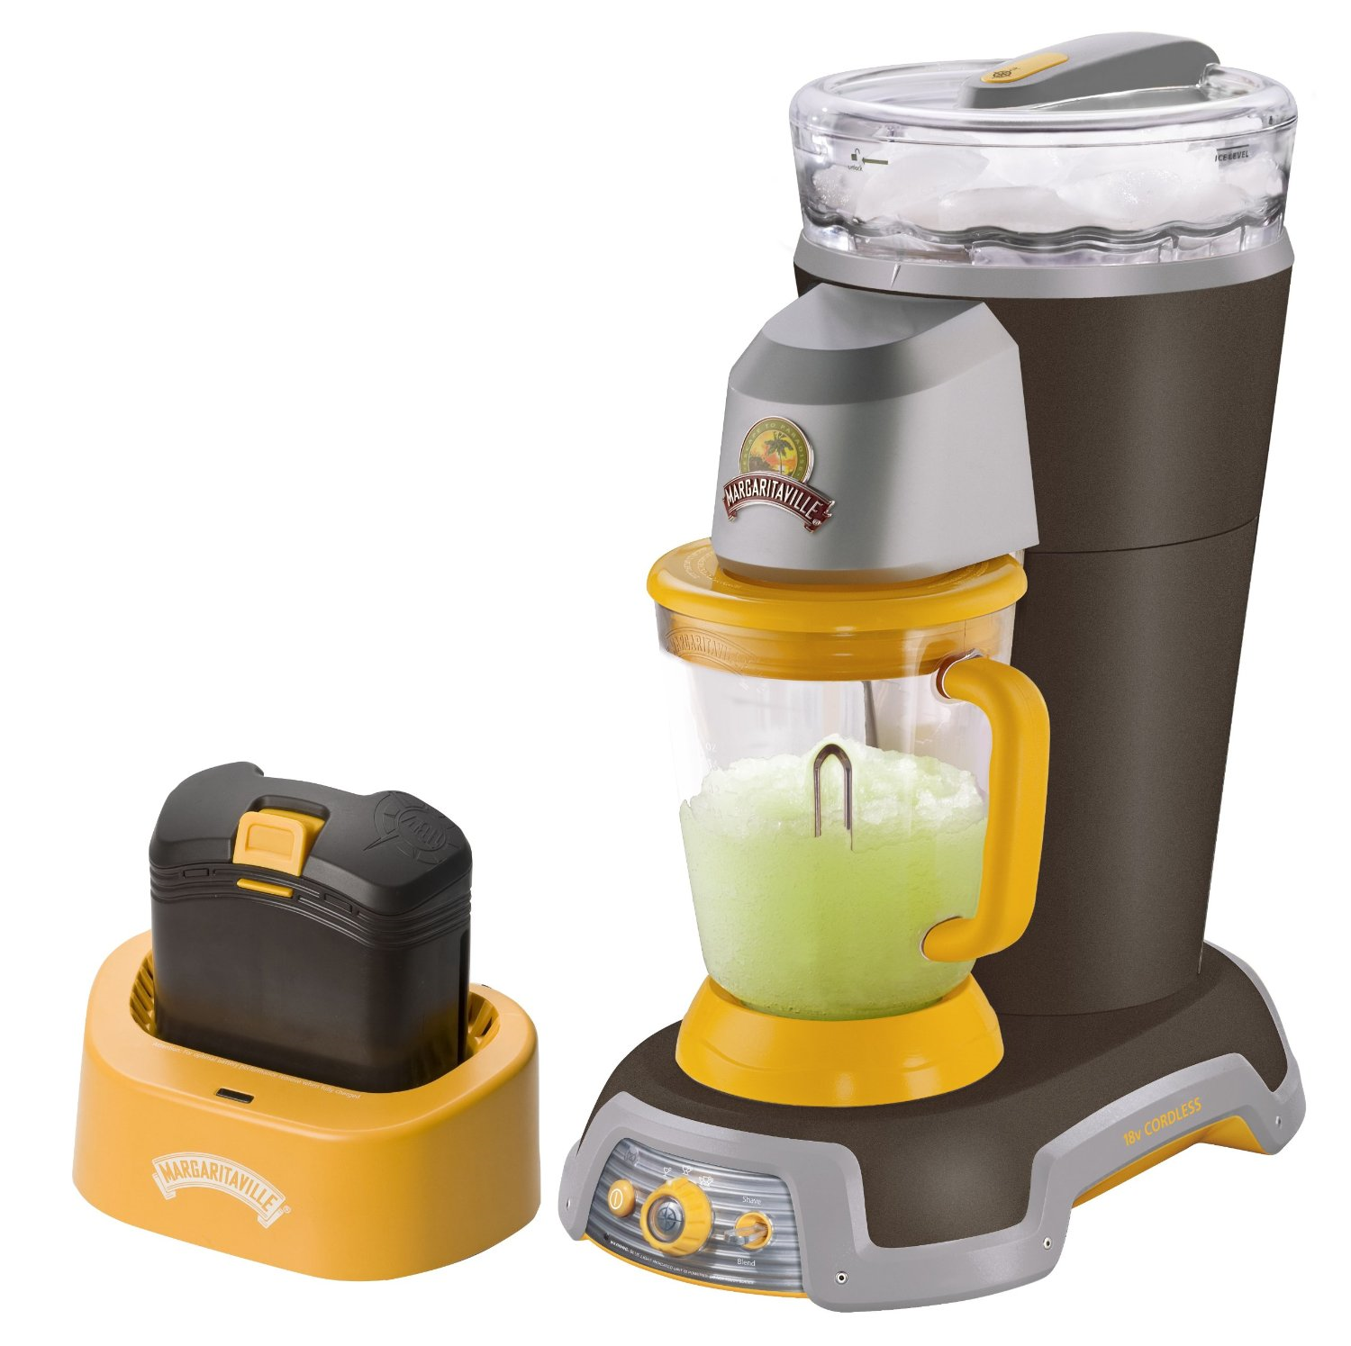
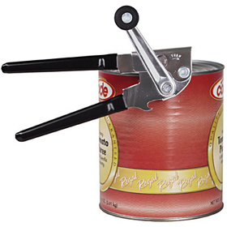

Emergency Water
In case of a disaster, untreated water may be used for human consumption. Water can be disinfected by boiling, chlorination, ionization, or by using purification tablets. Radioactive fall-out cannot be removed by any of these methods. Specific methods are required to purify by trained personal. In the event of an earthquake, contamination of usual safe water sources is possible, and all water sources must be inspected for contamination.
Possible water sources, other than tap water, are ice, water from water heaters, fruit juice, juice from canned vegetables & fruits, broth, carbonated beverages and stored emergency water at the facility.
Chlorine Solution for Disinfecting Water
QUANTITY OF WATER | CLEAR WATER | CLOUDY
1 Quart | 2-3 Drops | 5 Drops
1 Gallon | 10 Drops-20 Drops | 20 Drops
5 Gallons | ½ teaspoon | 1 teaspoon

Dosages will have to be adjusted for volume of water and appearance of the water. Normal household bleach is about 5.25% in strength. Dose the water with chlorine, stir well and let stand for 30 minutes. If the smell of chlorine is gone after 30 minutes the water can be considered safe to use. Water may taste of chlorine but is not harmful to consume.

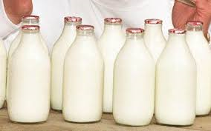
Instant Dry Milk Recipe
For 1/2 Cup of Milk
1/2 cup water
3 tablespoons instant dry milk

For 1 Cup of Milk
1 cup water
1/3 cups instant dry milk

For 1 Quart of Milk
4 cups water
1 1/3 cups instant dry milk

For 1 Gallon of Milk
4 quarts of water
5 1/3 cups of instant dry milk

For 5 Gallons of Milk
5 gallons of water
26 2/3 cups of instant dry milk

Prepare only the amount you will use within 4 hours since the milk has to be discarded after 4 hours at room temperature.

Directions for Preparing Milk

- Use cool water when possible as the powder tends to dissolve more readily in cool water.

- Stir the milk a lot, to dissolve the milk powder. Then let the milk sit for a little while and stir again. The protein in the milk powder blends easily if it gets a chance to stand after mixing.

- If you don’t have a refrigerator then wrap the milk in a wet towel. As the water evaporates, the milk will cool.

- Some people add a drop or two of vanilla to their milk to improve the taste. Other people add a spoonful or two of sugar for the same purpose. Consider these suggestions if the milk taste is not well accepted.

